Sensemaking Moment Analysis: Hab Crew 2004.05.03

Overall CEU scoring table, heat map, and CEU graph

Coherence | 3.0
Engagement | 3.0
Usefulness | 3.0
Overall | 3.0

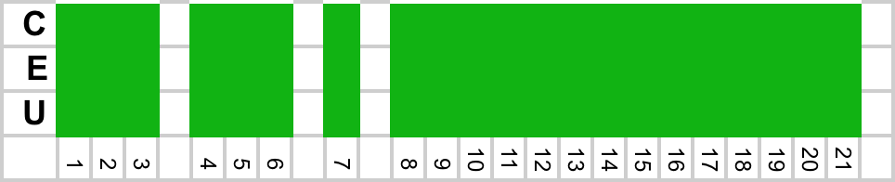

Overall scoring and heat map for Rutgers Group 1

Looking at the whole-session scores, the Overall score was the highest of all sessions analyzed, with no dips in any of the measures. For this session, there were no major sensemaking challenges or obstacles; only a few minor issues came up that were resolved within a few seconds. The analysis will focus on the period in timeslots 18 through 21 discussing some challenging occurrences and how they were dealt with.

CEU Graph for sensemaking episode

The full CEU grid provides further detail on what occurred in the episode and the CEU ratings in each timeslot:

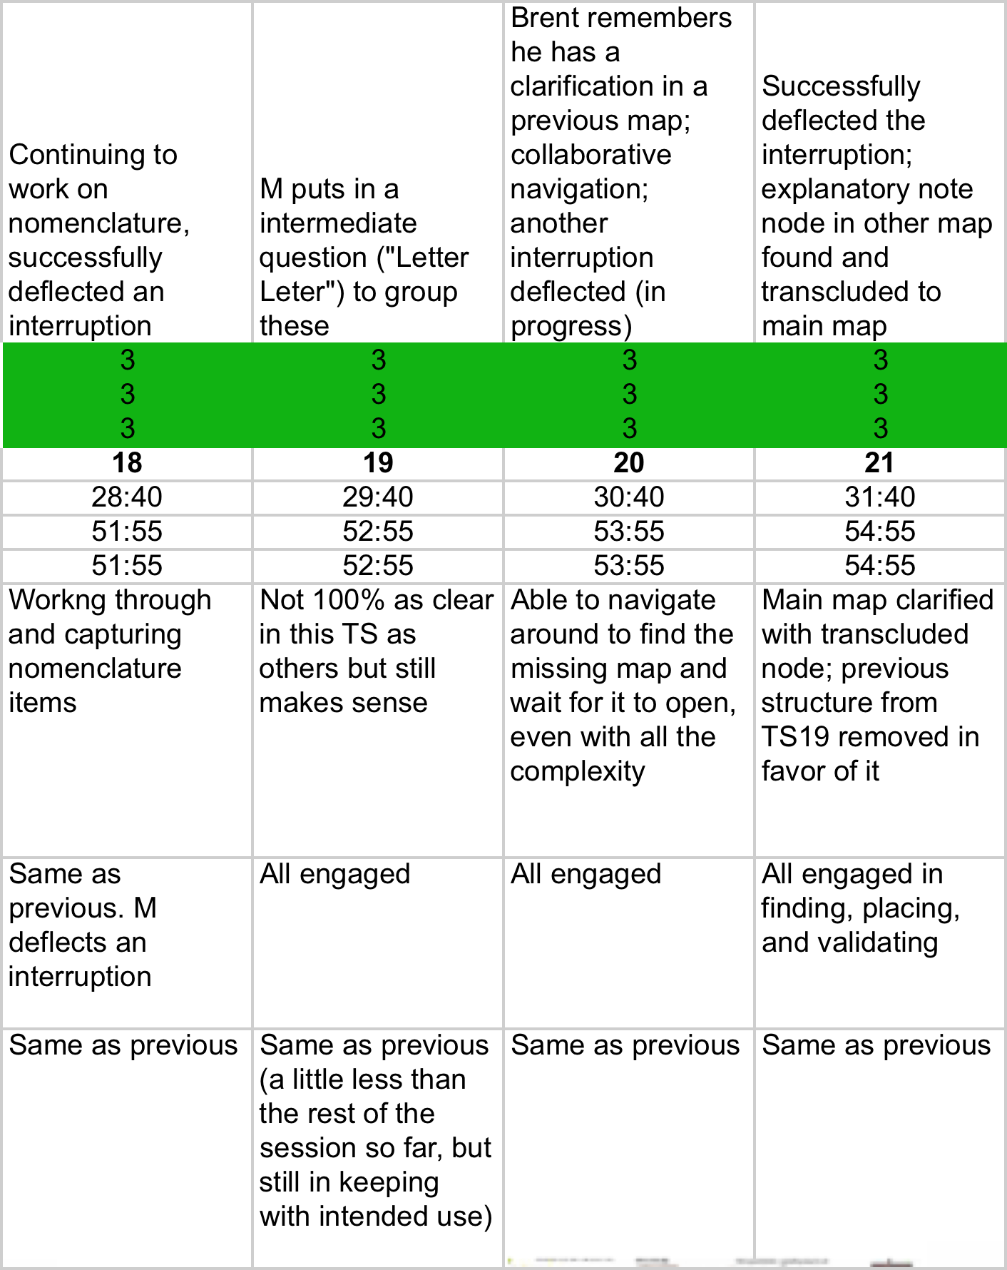
Full CEU Grid for sensemaking episode

Narrative description of the sensemaking episode

The sensemaking episode for this session spans the time from 51:07 (TS 18) to the end of the session at 54:59 (TS 21).

Timeslot 18 starts as the group is discussing the sample bag nomenclature, an unplanned topic which had emerged most of the way through the session. They had already successfully retrieved an explanatory node from a previous map that gave the specification for the nomenclature (“letter letter digit digit digit digit”) and were beginning to formulate the specifics names they wanted to use.

[51:07]
B: "Um well it would be coming up with what we want to use as our letter letters on the, on the site so we can have… like… SF for south face, WF for west face, EF for east face"
A:"OK"
[51:23]

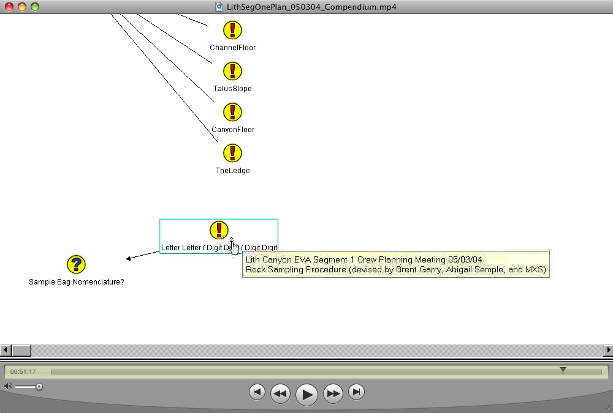

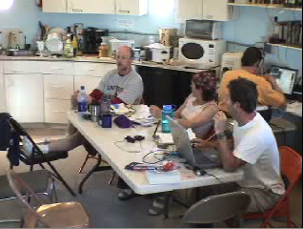
Figure 1: Screen and session at 51:17

They proceed with this unproblematically, identifying additional names, until M voices some confusion with the naming approach in general:

[52:15]
M: "…I don't understand how you use these, but you do, right? It's letter letter? Is that what it is?" A: [52:19-20] "Yeah"
A: "So our sample bag would be, like, S F slash um 2 1 slash zero 1. And that would be, um"

In the midst of this M. makes an (unprompted) grouping of the nomenclature nodes captured so far, using a Question node:

M: "So this is letter letter right?"
A: "Yeah that's all goes there in front of it"
A: "And then …"

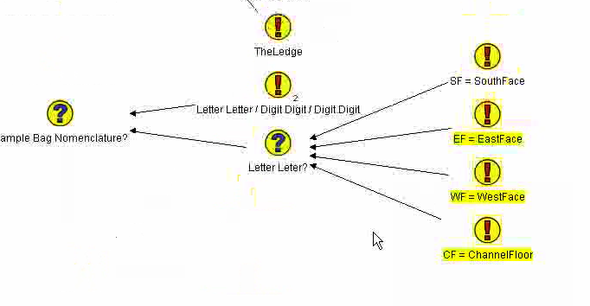
Figure 2: Screen at 52:48

M: "Allright."

But this grouping does not seem to help completely:

A: "OK. So, we know the digit digit thing. But the digit, the first digit digit"
A: "ha… this is gonna get confusing"
M: "Well that's why I'm writing it down"
[52:59]

B. suddenly remembers that he had previously mapped out an explanation for this in Compendium, which prompts M. to start looking for it, and B. and A. to help in the navigation effort:

[52:59]
B: "I have it in one of my Compendium maps from Pooh's Corner"
A: "Yeah he has put a note in"
M: "Oh you do?"
[53:03]

M. navigates up to the previously transcluded “Letter Letter / Digit Digit / Digit Digit” node and hovers over its Views indicator to reveal the other map that it’s located in:

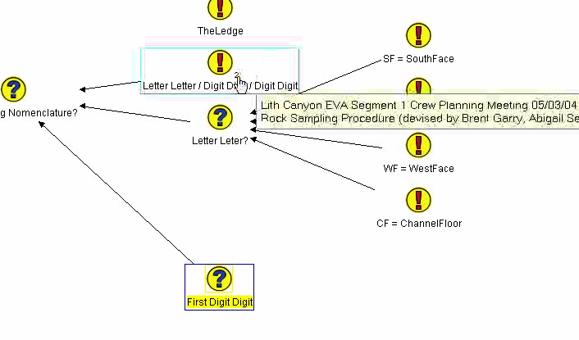
Figure 3: Screen at 53:07

He then opens the Views dialog to be able to navigate to that other map and see the node in its original context:

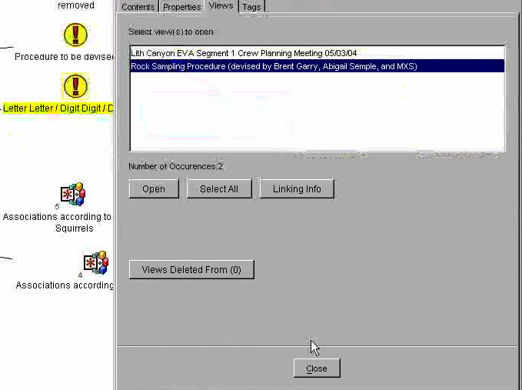
Figure 4: Screen at 53:12

[53:03]
B: "I have it as []…"
A: "Actually that might be a better…"
A: "I think it's that"
M: "Is it is it the one where, where it's uh"
B: "Could be"
B: "Rock sampling procedure"
A: "Yeah"
[53:10]

M. opens this map but that doesn’t show the participants what they thought would be there, so they continue to discuss and advise where to look:

[53:12]
B: "I thought it was used…"
A: "It goes in, yeah, it does it's where it goes into um, it's where it goes into your analysis map is where it is"
B: "Yeah I think it's in one of my analysis maps I know that much"
A: "If you can find Brent's analysis map it's in there."
[53:24]

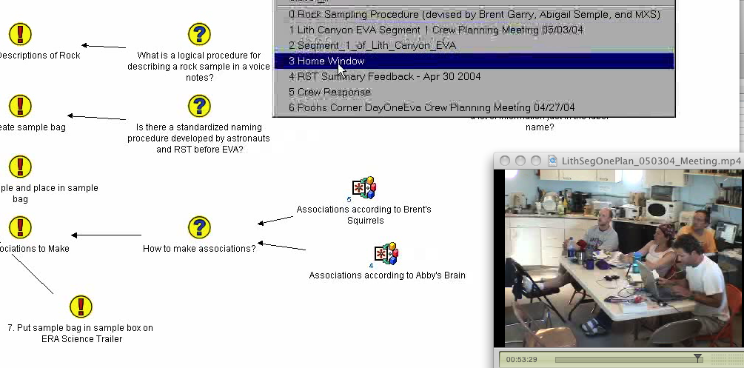
Figure 5: Screen and session at 53:29

M. states "I find it" and uses the Window menu to navigate to the Home Window (Figure 5). When he gets there, he finds and opens the "Day_2_of_Poohs_Corner_EVA" map (Figure 6) at 53:30.

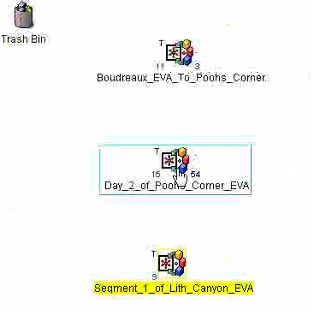
Figure 6: Screen at 53:30 (Home Window)
Within that, he finds and double-clicks on the “Brent’s Analysis” map at 53:35 (Figure 7). B. and A. both indicate it’s the right place to look. It takes a while to open due to the large number of photos it contains.

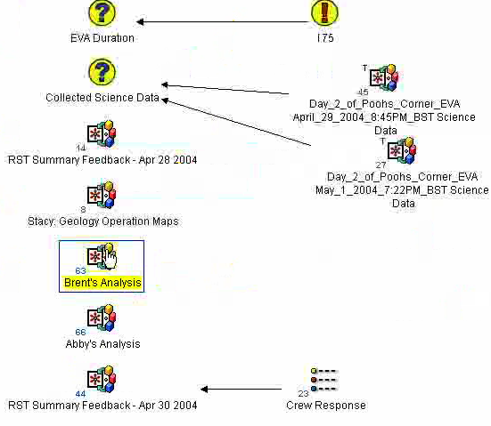
Figure 7: Screen at 53:35

[53:36]
B: "Yeah it should be in here."
A: "Yeah I think it was it was in there… one of the pictures from your sample bag."
[M: "C'mon " [waiting for map to open]
B: "There's a lot of photos"
M: "I know"
[53:43]

The map opens a few seconds later, but before they can talk about it other members of the team walk in talking about the need to get to another meeting. M. deflects them:

[53:46]
M: "Can we do that after we finish this?"
[continued discussion, asking how much more time M needs]
M: "Five more minutes."
[agreement, they leave the room]
[54:05]

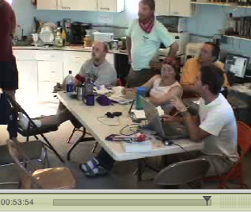
Figure 8: M. deflects an interruption

With the map open and attention restored, B. and A. direct M. in which node to find. He finds it and B. points out that the description they need is contained within the detail (“tag” referring to the asterisk detail indicator). M copies the node.

[54:04]
A: "we got we got" [pointing at screen] "go to the left sorry yeah"
A: "That one where it says 'note on sample bag naming', the tag in the corner explains"
B: "Yeah if you have, if you look at the tag"
M: "OK. I'm just"
B: "OK"
[54:15]

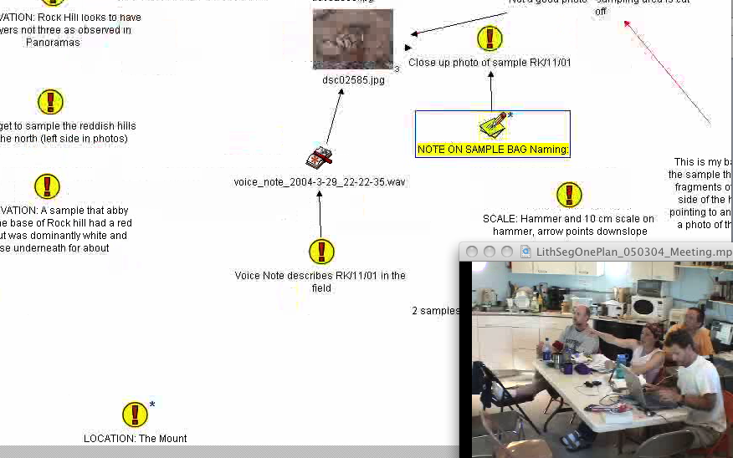
Figure 9: Finding the node to copy at 54:14

Using the Window menu, M starts to navigates back to the original map to place the transclusion in:

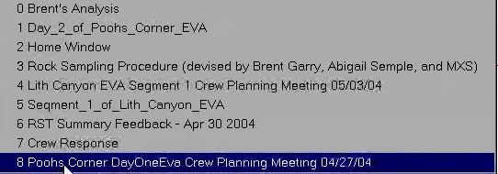
Figure 10: Window menu at 54:16

But he chooses the wrong meeting map. A. corrects him and directs him to the right choice on the Window menu.

[54:18]
A: "You're in the wrong one. You're in Pooh's Corner"
M: "Of course. So many maps now. Uh"
A: "uh -- down, down, down number five."
[54:26]

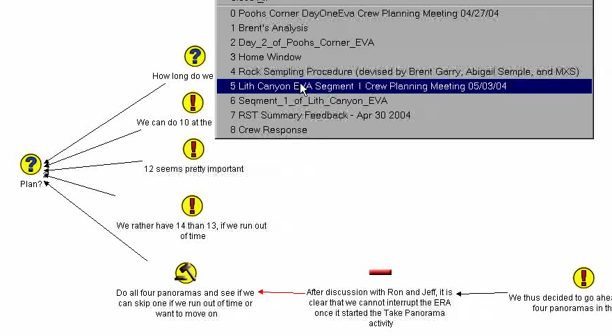
Figure 11: Screen at 54:26 (navigating out of the wrong map)

M. gets back to the correct map, pastes in the transclusion of the "NOTE ON SAMPLE BAG Naming:" node, links it to the “Sample Bag Nomenclature” Question, then hovers over the “tag” (asterisk indicator) at B.’s direction to examine the contents:

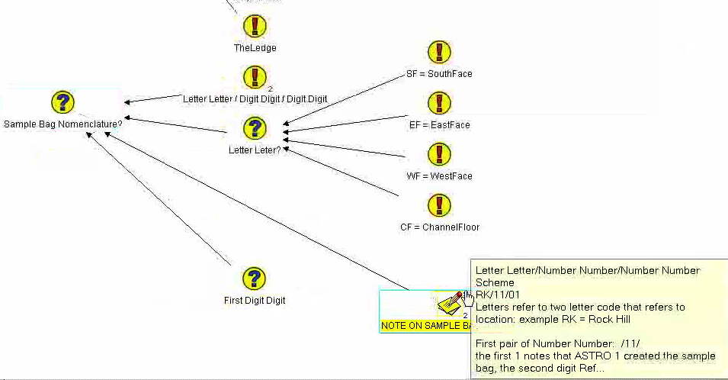
Figure 12: Screen at 54:35 after pasting, linking, and hovering

[54:31]
B: "k if you look at the tag"
A: "Yeah."
B: "So..."
M: "OK"
B: "The letter refers to the location name"
[54:37]

Having established that it’s the correct and more complete description, M. realizes he can remove the grouping Question node (“First Digit Digit”) node he had created earlier (confirmed by A.):

[54:37]
M: "OK so this I can just..."
A: "Yeah."
M: "delete"
[54:39]

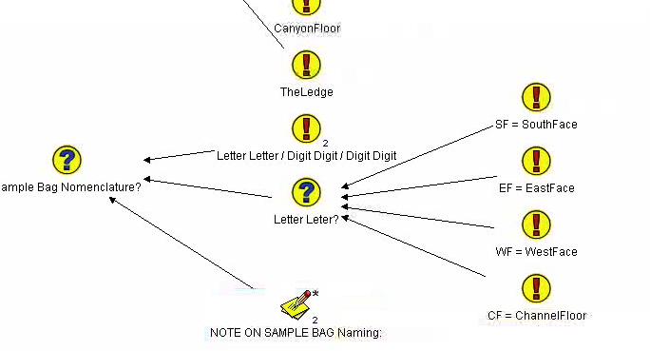
Figure 13: Screen at 54:50, final form of map after deleting question node and linking the transcluded node to "Sample Bag Nomenclature"

The team comments on the changes. B. starts to review in depth but M. cuts him off to conclude the meeting:

[54:39]
A: "So that, explains it…"
B: "Especially with the tag.”
A: "that neatly…"
B: "The first pair number, the first yeah the first digit in that first pair denotes which astronaut…"
M: "Alright. They can read it. They will get this map. We, uh, we have to shut down so we're gonna end the meeting here, we hope that the RST will have a good meeting."
[54:59]

